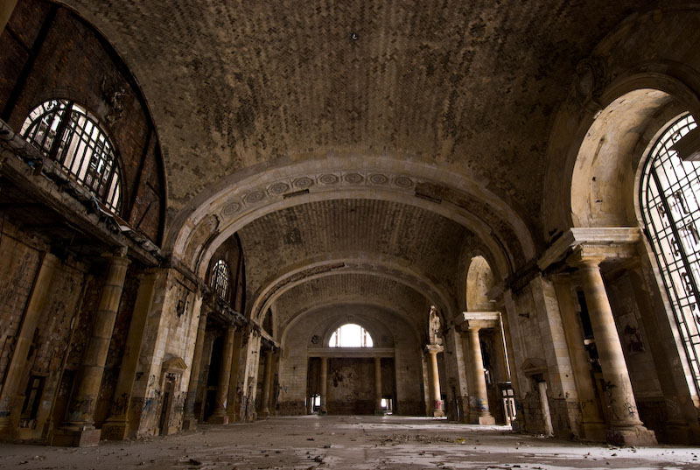

Interested in Participating, email us @:

risingfromashes2009@gmail.com

No later than October 12th

* *Rising from the Ashes*
* An Honors Directed Study focused on improving the image of Detroit

November 17th – 23rd

Undergraduate Library (UGL)

Rising from the Ashes

A Look at Detroit through New Eyes

# An Art Competition to Showcase the *Real* Detroit

## *A Look at Detroit Through New Eyes* is an art competition whereby individual students will ask themselves what Detroit is as embodied through a site of their choosing. Using whatever art medium, the student will then capture the *real* Detroit as seen by them and then describe their concept in a brief narration so that others may understand. Entries will be judged by a panel of judges that will determine the entries that best captures the *real* Detroit as seen through new eyes.