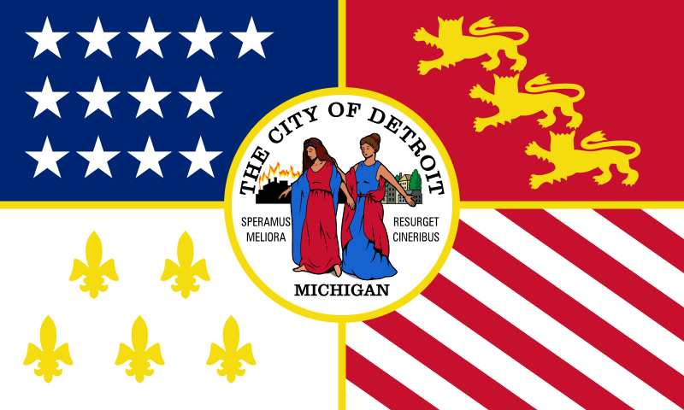

**A Look At Detroit through New Eyes**

Exhibition Guidelines

|  |
| --- |
| **An Art Exhibition to Showcase the *Real* Detroit** |
| In recent times, the once great city of Detroit has fallen into disrepair as citizens, money, and jobs have fled the area in search of a new place to call home. Fewer individuals in the city has created a lower tax base from which the city may draw to upkeep the city thus leaving the city of today – a city filled with vacant homes, crumbling buildings, schools with no students in them, and those individuals who remain unable to leave. Yet this is not the *real* Detroit. The real Detroit lies hidden behind the negative perceptions, waiting to be revealed to others. Only in our city could one appear as both black and white – the good and the bad – and still live on to tell the tale. But to truly tell our tale we must pull back the familiar Detroit and reveal its true identity by looking at Detroit through new eyes.  *A Look at Detroit Through New Eyes* is an art exhibition whereby individual students will ask themselves what Detroit is as embodied through a site of their choosing. Using whatever art medium, the student will then capture the *real* Detroit as seen by them and then describe their concept in a brief narration so that others may understand. By taking the city that has for so long been seen as broken and seeing it through “new eyes”, the true beauty that Detroit holds may be realized. It is by seeing Detroit through these “new eyes” that others may see a side of Detroit few have ever considered taking – and hopefully washing away common misconceptions so that a new outlook may be applied to our great city. |
| **Guiding Principles** |
| In developing this exhibition, *Rising from the Ashes* feels that each entry should:   * be beautiful, useful, and humane: a classic in its own right connecting the audience to the good or bad that it portrays * allows the audience to not think in terms of *I* but rather *We*: how does this represent all of us, not just me * display the good, bad, and unknown aspects of the city * urge viewers to see Detroit in a different way and share it with others they know * be creative and original, a personal statement about the city as seen by the author   Overall, *Rising from the Ashes* is looking for new classics to be seen and interpreted by all audiences so that they may form new opinions, shape old ones, or learn something new. |
|  |
| **Outline of Exhibition Events** |
| Competition winners will be determined based on not only the guiding principle of the competition but also the authors meeting of artwork guidelines. Participants upon completion of required documentation (see **Summary of Application and Selection**) will be able to capture their desired rendition of Detroit. Participants will be initially assessed on the information provided in their application. However, at the conclusion of the exhibition participants will then be reviewed, in addition to their pre-screening, on the ability to meet the following three categories:   * Creativity * Content * Presentation   The specific requirements for each of these three categories is described below in the section titled **Artwork Submission and Revision by Panel of *New* Detroit**. Upon review by the Panel of *New* Detroit (a panel comprised of various WSU professors in various fields whom hold a different outlook on the city of Detroit), recognition will be given to all participants. Special recognition will be given to individuals who not only meet the criteria but also go beyond such and display the city in a “new” light. These individuals will then be given the opportunity to have their work displayed in the new CommunityEngagement@Wayne offices. Other students will also be given the opportunity to display their work in various other venues if they so wish.  **Exhibition Schedule**   |  |  | | --- | --- | | **October 12th** | Email of Interest in Exhibition | | **October 31st** | Application Deadline | | **November 16th** | Last Day to turn in Artwork  (no later than 3PM) | | **November 17th – 20th** | *A Look at Detroit Through New Eyes* Exhibit | | **November 23rd** | Winners Announced |   *All dates are subject to change – any changes will be given to all participants via email.* |
| **Summary of Application and Selection** |
| To become a participant in *A Look at Detroit Through New Eyes*, prospective participants must fill out the Application of Participation and agree to the terms and conditions as outlined in this document. Once the Application and Terms & Conditions have been submitted, both *Rising from the Ashes* and the Panel of *New* Detroit will screen individual participants to make sure one qualifies. Each participant will then be notified upon being accepted into the competition. |
| **Artwork Requirements** |
| Below are listed the minimum requirements for any and all artwork submitted into the competition. Remember, these are just the minimums – participants are encouraged to think creatively while still abiding to the rules listed.   * Photographs, paintings, and drawings MUST be mounted so that they may be easily displayed – all other medias must also be easily mounted and/or displayed* * Photographs, paintings, and drawings MUST NOT BE any smaller than 8.5 x 11 * Artwork must be appropriate to the theme of the exhibition * Artwork must not be obtained or created through any form of unlawful behavior * MUST be original artwork done by participant   *Any questions regarding display of certain media types may be directed to *Rising from the Ashes* via email |
| **Artwork Submission and Revision by Panel of *New* Detroit** |
| As noted earlier, each participant must complete an Application and be pre-screened for admittance into the competition. Upon completion of such, participants will be evaluated in the following three categories: Creativity, Content, and Presentation.  **Creativity**  Each piece must be an original depiction of the city of Detroit that abides by the rules and philosophies as given by *Rising from the Ashes*. It must embody the vision of the city as seen through the eyes of the participant – not that which either the Panel or Rising from the Ashes may see.  **Content**  Each piece must portray some aspect of the city of Detroit. The Panel of *New* Detroit, comprised of individuals knowledgeable in Anthropology, the Historical Aspect of the city, and American Ideology, will use their interests to see whether each participant has taken his/her embodiment of the city to a deeper level than transcends visual aesthetics.  **Presentation**  Each piece should hold some form of purpose in its presentation so that the viewing audience can grasp the artist’s vision. As the Panel of *New* Detroit consists of professors knowledgeable in all aspects of art, art technique, and art history, such expertise will be used to evaluate each art piece in its artistic merit. |
| *It must be noted that artwork will not be returned to their respective owners if the participant agrees to allow it to be permanently displayed.* |

|  |  |
| --- | --- |
| **Name:** | **Access ID:** |
| **College Level:** Freshmen Sophomore Junior Senior | |
| **Major:** | |
| **Email: *WSU***  ***Other*** | **Phone:** (   )  *If needed to contact you immediately regarding the art competition.* |
| **Art Medium:** Film Digital Painting Sketch  Other:  **Projected Artwork Size:** | |
| ***Please answer completely.***   1. **What are you capturing in your art medium (ex. person, place, thing, etc.)?** | |
| 1. **What do you hope to embody in your artwork (ex. themes, emotions, ideas, etc.)?** | |
| 1. **What does Detroit mean to you?** | |
| ***Please select one from below.***  **I hereby give permission to *Rising from the Ashes* to display my artwork on public display.** | **I hereby deny *Rising from the Ashes* to display my artwork on public display.** |



**A Look At Detroit through New Eyes**

Application of Participation